
Grade 2
Sudoku Puzzles and Patterns

Description: | Students will:  Draw a grid using paint tools.  Experiment with ways to divide it into 16 parts.  Draw four motifs.  Discuss it as an array of rows and columns.  Save puzzle solutions in a flap.
Project View | 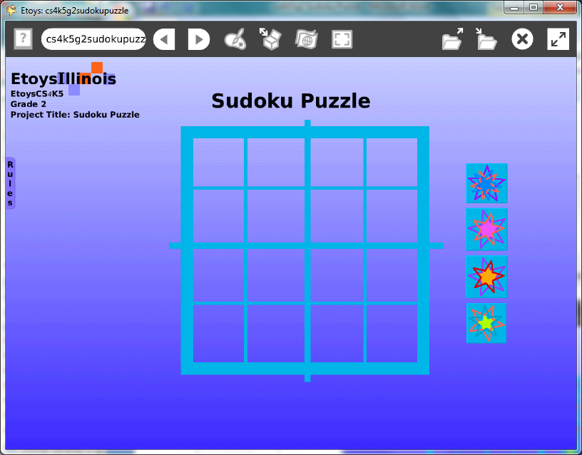
Etoys Quick Guides | Click the question mark in Etoys to open the set of interactive tutorials  for basic tools and techniques.
Vocabulary: | Grid, half, quarter, rows, columns, estimate, solve, patterns, rules,
Lesson 1:  Paints: Straight Line Tools  Halo Handles: Size, Color, Copy  Object Catalog: Maker Buttons  Navigator Bar: Keep Find Projects | Making the grid: draw a grid with three different sizes of brushes to show the outline, divisions of the square in half horizontally and vertically and smaller divisions of the quarter squares. Give them time to practice drawing even divisions with the paint tools. Or, open a playfield and use the white menu: playfield options: make graph paper for more accurate grids.  Draw a design motif. Copy it and change the colors and/or size.  Get four Maker Buttons from Supplies and put a design motif on each.  Keep the project: NameSudoku
Lesson 2:  Supplies: Text  Supplies: Add a Flap  Navigator Bar: Keep Find Projects | Plan the finished puzzle: decide where the grid and maker button designs should be for easy use by players.  Use Text from Supplies and type a title and the rules.  Add a flap for the rules and solutions.  When all the puzzle pieces and text are in their final locations. Open the Viewer for the grid, select the white menu and click: be locked. This will keep the grid from reacting to the cursor.  Discuss the grid as an array of rows and columns. Ask students to make a row and then move the same pieces to make a column. Ask student s to put a motif at row 2 column 3, etc.  Hint: An easy way to remove all the Sudoku pieces from the grid is to hold down shift key then click and drag a box around the objects to be discarded.  Keep the project: NameSudokufinal e.g. Katesudokufinal  Give students time to enjoy their puzzle and the ones their neighbors made.  Solutions could be collected in the flap as a reference. Ask students if incorrect solutions should be kept. Why? Why not?  An additional flap could store designs that are not Sudoku solutions but are patterns students want to keep.
Standards: | Common Core Standards  Mathematics: 2.OA.3  Bloom’s Taxonomy/Cognitive Domain:  Knowledge: knows  Application: uses  NETS  1. a, c
Resources: | Etoys Help Quick Guides: always available in Etoys. Open Etoys and click the question mark to open a set of interactive tutorials of basic tools and techniques.  www.etoysillinois.org projects, lesson plans, software download  www.mste.Illinois.org more math, science, and technology resources  www.corestandards.org Common Core Standards  www.squeakland.org software and Etoys projects  www.nctm.org Standards and Focal Points for each grade level
kh January 2011

